**BX2174: RESEARCH AND DECISION MAKING**

ASSESSMENT TASK 2 COLLEGE OF BUSINESS, LAW AND GOVERNANCE

**GROUP TASK COVER SHEET**

|  |  |  |  |  |  |  |  |  |  |
| --- | --- | --- | --- | --- | --- | --- | --- | --- | --- |
| *Students*  *Please sign, date and attach cover sheet to front of assessment task for all hard copy submissions* | | | | | | | | | |
| **SUBJECT CODE** | BX2174 | | | | | | | | |
| **STUDENT FAMILY NAME** | **Student Given Name** | **JCU Student Number** | | | | | | | |
| i.Tran | Le Binh | 1 | 3 | 4 | 7 | 6 | 1 | 1 | 2 |
| ii. Nguyen | Thi Bich Phuong | 1 | 3 | 3 | 9 | 1 | 1 | 3 | 5 |
| iii. Chua | Alexander Kiah Hng | 1 | 3 | 2 | 8 | 8 | 6 | 6 | 2 |
| iv. Chen | Zhiqing | 1 | 3 | 3 | 7 | 4 | 9 | 4 | 0 |
| v. Ngu | Shwe Eain | 1 | 3 | 5 | 3 | 1 | 2 | 8 | 2 |
| **ASSESSMENT TITLE** | Research Report | | | | | | | | |
| **DUE DATE** | 11/05/2018 | | | | | | | | |
| **LECTURER NAME** | Sven Dahms | | | | | | | | |
| **TUTOR NAME** | Sven Dahms | | | | | | | | |
| **Student Declaration**   1. This assignment is our original work and no part has been copied/ reproduced from any other person’s work or from any other source, except where acknowledgement has been made (see *Learning, Teaching and Assessment Policy 5.1*). 2. This work has not been submitted for any other course/subject (see *Learning, Teaching and Assessment Policy 5.9*). 3. This assignment has not been written for us. 4. We hold a copy of this assignment and can produce a copy if requested. 5. This work may be used for the purposes of moderation and identifying plagiarism. 6. We give permission for a copy of this marked assignment to be retained by the College for benchmarking and course review and accreditation purposes.   [Learning, Teaching and Assessment Policy](http://www.jcu.edu.au/policy/allitoz/JCU_076643.html) 5.1. A student who submits work containing plagiarised material for assessment will be subject to the provisions of the [Student Academic Misconduct Requirements.](http://www.jcu.edu.au/policy/allitoz/JCUDEV_005375.html)  **Note definition of plagiarism and self plagiarism in Learning, Teaching and Assessment Policy:**  **Plagiarism:** reproduction without acknowledgement of another person’s words, work or expressed thoughts from any source. The definition of words, works and thoughts includes such representations as diagrams, drawings, sketches, pictures, objects, text, lecture hand-outs, artistic works and other such expressions of ideas, but hereafter the term ‘work’ is used to embrace all of these. Plagiarism comprises not only direct copying of aspects of another person’s work but also the reproduction, even if slightly rewritten or adapted, of someone else’s ideas. In both cases, someone else’s work is presented as the student’s own. Under the Australian *Copyright Act 1968* a copyright owner can take legal action in the courts against a party who has infringed their copyright.  **Self Plagiarism:** the use of one’s own previously assessed material being resubmitted without acknowledgement or citing of the original. | | | | | | | | | |
| **Student signature(s)**   1. Tran Le Binh Submission date 11/05/ 2018 2. Nguyen Thi Bich Phuong Submission date 11/05/ 2018 3. Chua Alexander Kiah Hng Submission date 11/05/ 2018 4. Chen Zhiqing Submission date 11/05/ 2018 5. Ngu Shwe Eain Submission date 11/05/ 2018 | | | | | | | | | |

**TABLE OF CONTENT**

**1. Executive Summary: 2**

**2. Introduction and research questions 3**

**3. Brief literature review 4**

**4. Overview of the method 5**

**5. Results and Discussion 6**

**5.1. Results 7**

**5.1.1. Experience 7**

**5.1.2. Language 8**

**5.1.3. Education 9**

**5.1.4. Working attitude 10**

**5.1.5. Skills 12**

**5.2. Discussion 13**

**5.2.1. Experience 13**

**5.2.2. Language 13**

**5.2.3. Education 13**

**5.2.4. Working attitude 14**

**5.2.5. Skills 14**

**6. Limitations 15**

**7. Conclusions and Recommendations 15**

**7.1 Conclusions 15**

**7.2 Recommendations 16**

**Research question: What are the requirements that employers expect from the Front Office staffs in the hospitality industry?**

# Executive Summary:

* The purpose of the report is to access and investigate the primary requirements when the employers recruit the Front Office position in the present labor market. Our literature is based on China but we will focus only on Shanghai and compare the findings with that of Singapore.
* The research question of the report is “The requirements that the employers expect from the Front Office staffs in hospitality”.
* The report provides the secondary data from collecting the information through some websites like Jobstreet, Indeed, job advertisements and the article called “Skills and Work in the Hospitality Sector – The Case of Hotel Front Office Employees in China”. After that, the diagrams are created to analyze, compare the difference employment in Singapore and Shanghai.
* The report mainly uses the qualitative data to examine the research question. It means that there is not any questionnaires or surveys conducted.
* There are limitations of us only used the secondary data via job finding websites. The tables, diagrams and charts attached in this report are all based on those secondary data and the results are our interpretation of the findings.
* The result shows that it is important to have at least a relevant degree or diploma to secure a front line job in Singapore as well as in Shanghai. English and Chinese are the most important languages and as for experiences, 1-2 years or 1-3 years is required in both countries. Communication skills, customer service skills and teamwork skills are vital in both countries and various working attitudes are essential according to a hotel’s expectation.

# Introduction and research questions

This report’s topic is Front Office position in Hospitality Industry. In fact, the hospitality industry annually provides 292 million jobs, generates 7.6 trillion USD and contributes 10.2% global GDP (Ecole Hoteliere Lausanne, 2018). The Front Office position is considered as the first and final contacting point between customers and services to build up brand awareness and reputation for hospitality industry. Besides making the first impression of the customers, they are responsible for many other important front tasks such as telephone operator, informer, cashier, and receiving feedback. Therefore, the Front Office position plays an important role in the hotel development.

It is extremely challenging for employers to hire a front office staff because it is taking part in a vital place and the hotel’s image is also very much relying on them. Generally, the customers are more serious and expect more on service quality in the hospitality industry as it’s what they’ve paid for. The front office is an important position in every hotel where skillful staffs and proper training are required to minimize the mistakes. Thus, the employers have a high demand and expectation for this position in the modern and integrated society.

The two developed cities, Singapore and Shanghai attract lots of tourists each year and there is a high demand in job labor for Front Office position. Hotels tend to offer jobs to the employees who have already graduated from further education relating to hospitality or professionally working in the guest service area and good working attitude. In some hotels, however, the entry level of Front Office still ranges from the secondary level to higher education, and sometimes allow those who do not have any experience at all. This leads to an overwhelming quantity of Front Office staffs working in this position.

The research question of the report is “What are the requirements that employers expect from the Front Office staffs in the hospitality industry?”Through this research question, it will look into the problems happening in both Singapore and Shanghai in hospitality industries about Front office jobs by providing research, results and interpretations. It includes the facts like the percentage inexperienced staff hired, why secondary education certificates still have the opportunity to work in the industry as a front line staff, the importance of knowing different languages to communicate with the guest and lastly, what kind of knowledge and skills are essential in the workplace.

# Brief literature review

Front line staffs in hotels undertake an important task in helping to build up the hotel’s reputation and image. Because of this - therefore, the skills and quality of employees must be taken into consideration during the selection process of hiring new staff as this is among the most important factor for the competitive success of the hotel. Singapore and China have both been established to be one of the most popular tourist destination. With rapid urbanization and the increase of attractions, the tourism industry has been booming. Due to the increase of tourists visiting per year, the hospitality industry is also affected and more hotels are needed.

The tourism and hospitality industry have not only provided a lot of job openings and opportunities but it has also become a main way to resolve employment problems in China. In 2003, more than 38.9 million jobs were supported just from the hospitality industry (Hai‐yan & Baum, 2006) Although tourism has developed rapidly and there has been a growth of human resources in the industry, China is still faced with the problem of a shortage of qualified personnel. The service quality, qualifications of staff and management skills are unable to keep up with the needs of rapid tourism development. Problems such as low quality of skills and low entry level of employees are also problems faced by the industry that needs to be resolved fast. One key way to resolve or aid this problem is to conduct a survey and investigate what skills are required in the future so as to take advantage of new opportunities to enhance the development of hospitality in other countries such as Singapore and China. (Hai‐yan & Baum, 2006).

The study conducted by Kong Han Yai and Tom Baum is based on a survey that was conducted in major tourist cities in China such as Shanghai and Beijing. In both areas, the hotels were randomly selected based on their star rating and questionnaires were distributed to the front line staff working at those hotels. The questionnaires were then collected on site once the staffs had completed it. A total of 350 questionnaires were given out and 276 of those collected contained usable data which was what formed the basis of this study. From the results collected, Kong and Baum were able to analyse the front line staff requirements of hotels in China.

Based on the findings, in terms of the important skills for front line workers, the respondents in Shanghai listed that Communication skill is considered as the most important and Professional and Ethical standards such as ... is considered as a second most important. This matches our findings based on Singaporean hotels where large number of hotels listed that Communication skills is also known as their main requirement as well. In addition to communication, the skills of leadership, teamwork and interpersonal were also listed by both Singapore and China. (Hai‐yan & Baum, 2006).

# Overview of the method

This report will collect qualitative data to examine the research question – “Requirement that the employers expect from the Front Office staffs in hospitality”. The report will not conduct the questionnaires to clarify this research question due to the unreasonable providing the questionnaires to the students in the university to answer. Because, the students do not have any working experience and do not have sufficient vision about how many requirements from the employers when they recruit. Additionally, the report cannot use quantitative data due to the unavailable resources, the meaningless analysis from the information.

Qualitative data contains the information where meaning is explained by words (Saunders et al, 2016). Qualitative data is gathered by the job advertisements on several like Jobstreet, Indeed, job advertisements. Through this vehicles, all requirements from the employers are demonstrated clearly and sufficiently. Apart from this, the reliable information is provided through the practical employment advertisements in the labor market which will be given below. This makes the research more meaningful, valid, persuasive and accurate.

Through the qualitative data, the report uses the method of categories of meanings. This means that the information is divided into 5 themes in terms of Experience, Language, Education, Working attitude and Skills. The purpose of generating themes is to simplify the research analysis by comparison and interpretation, reduce unnecessary and irrelevant information, emphasize the noticeable requirements for each themes, outline the future requirement tendency for Front Office position in Hospitality industry. If there is no theme, the research will become sophisticated, less focus on the outstanding requirements from the employers. Last but not least, it will not indicate the differences between the past and presence when the employers recruit, which results in the inertia in the development in Hospitality industry.

This report applies the deductive approach to clarify the theory by the observation and interpretation of collected data (Saunders et al, 2016). For the data collected, the report chooses 12 hotels in Singapore and Shanghai for sample procedure. Moreover, the report also chooses 68 hotels in Singapore and Shanghai for actual sample. The data is collected and analyzed through 7 steps.

* Step 1: choose 3-5 star hotels as the range of conducting the research where there is the recruitment advertisement of Front Office position
* Step 2: find 6 hotels in China and 6 hotels in Singapore to identify the primary themes.
* Step 3: set up 5 primary themes in terms of Experience, Language, Education, Working attitude and Skills
* Step 4: classify the information and place it into appropriate themes
* Step 5: select 34 hotels in Singapore and 34 hotels in Shanghai to establish the diagrams and calculate the percentage that how many hotels have the criteria for each theme.
* Step 6: provides the table, the pie chart, the bar chart so as to identify and analyze the main distinctions between 2 countries
* Step 7: compare, analyze the data, provide the factors that leading to this results and draw conclusion

The research philosophy for the report is the ontology. There is a reality that Front Office position does not belong to the casual labor – it is a white-collar occupation. Front Office position is known as the first contact point between customers who are not only the local people but also the international tourists, which make the impression from the customers so as to rate and assess the customer service. Therefore, there is compulsory to generate some requirements for employing this position in terms of Experience, Language, Education, Working attitude and Skills.

The strategy of gathering data is the approach of netnorgraphy by analyzing the documentary and the secondary data (Saunders et al, 2016). The article called “Skills and Work in the Hospitality Sector – The Case of Hotel Front Office Employees in China” will play a vital role to strengthen the viewpoint of literature review. The available of secondary data from the websites such as Jobstreet, Indeed, hotels’ advertisements will contribute the accuracy of the report.

The report takes a positivist stand because it is built on previous knowledge. From the survey, we can count how many hotels require specific skills and summarize the results in numbers, which we can then compare with our own research from job advertisement.

# Results and Discussion

Front Office position plays an important role in Hospitality Industry where the staffs are the first and last contacting point with the customers when they arrive the hotels (Westford School of Management, n.d). Several hotels have different criteria when employing Front Office staffs in Singapore and Shanghai. The below statistics will show the difference division in terms of Experience, Language, Education, Working attitude and Skills in both 2 countries.

## Results

### Experience

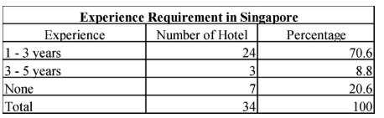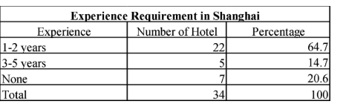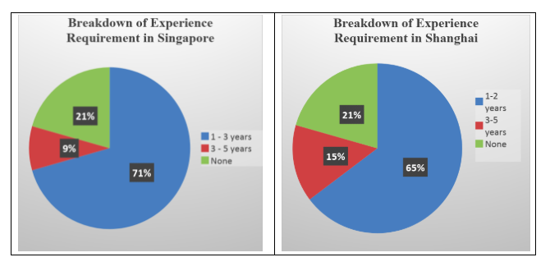

The given pie charts above reveal that in Singapore, 71% employers require the front office position to have at least 1 to 3-year experience in the hospitality area. However, in Shanghai, the requirement is lower by 6% with 65% of the hotels requiring 1 to 2-year experience. 9% of hotels in Singapore require the front office position to have a minimum of 5 – year experience in the hospitality industry. In contrast, Shanghai has a higher percentage (15%) that requires 5 – year experience. Interestingly, the percentage of no experience required for both countries are the same being 20%. This shows that about a quarter of hotels for both Singapore and Shanghai are willing to hire candidates that have no experience in the industry.

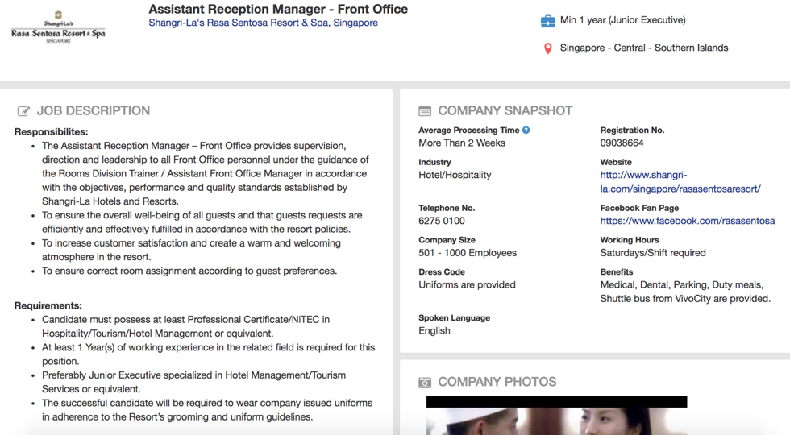

Figure 1. Sample job advertisement for Front Office staff for Shangri La Hotel Singapore

Shown above is a job advertisement found on Jobstreet for a Front office manager. We are able to see from the job requirements that the candidates must have at least 1 year of working experience in the hospitality industry to be applicable for the job.

### Language

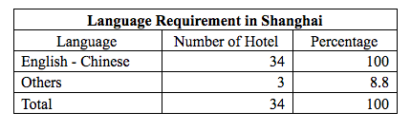

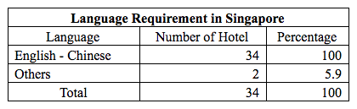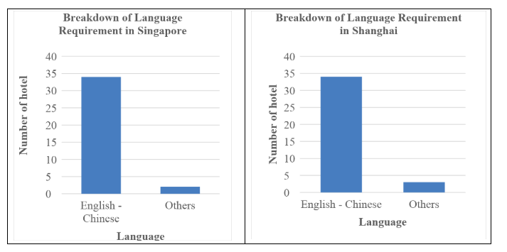

The bar charts above provide the information that both Singapore and Shanghai, English and Chinese are the primary languages that front office staffs must be proficient with for 100% of the hotels. A small percentage of hotels require other languages to be spoken, which is 5.9% in Singapore and 8.8% in Shanghai.

### Education

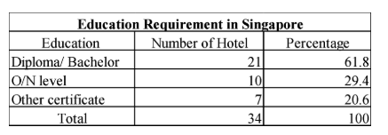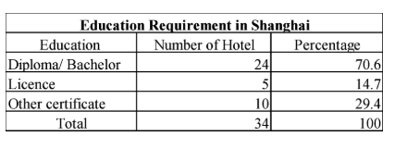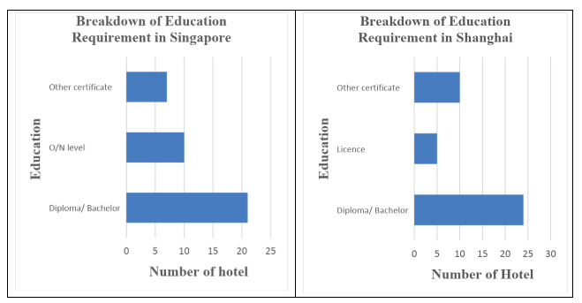

The bar charts show that in Singapore, the number of hotels that require at least a diploma or basic Bachelor degree is quite similar to the number of hotels in Shanghai. To be specific, 21 Singaporean hotels require Diploma or Bachelor degree and 24 hotels in Shanghai require Diploma or Bachelor degree. Which means that within 100 percent, there is over 60% per cent that the employers require higher education.

In Singapore, if the applicant does not have a diploma or degree, if they have obtained a secondary school O/N level certificate, 29.4% of hotels will hire them for front line positions.

In Shanghai on the other hand, our research shows that if the applicant does not minimally possess a degree or diploma, they are required to go for a course and get a license to work in the hospitality industry. In Shanghai, 5 hotels think that possessing License certificate is one of primary criteria to employ Front Office Staffs, which is only 14.7%

### Working attitude

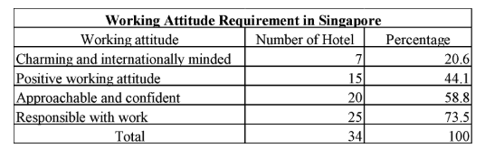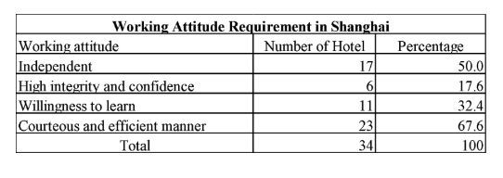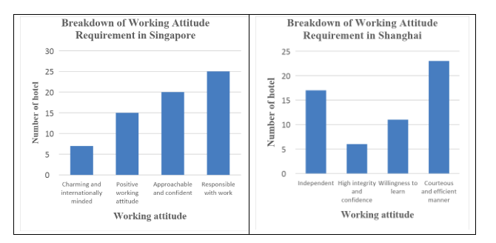

For the working attitude requirements in Singapore, ‘Responsible with work’, ‘Approachable and confident’, ‘positive working attitude’ and ‘charming and internally minded’ were the 4 main attitudes that appeared on the job advertisements. The most frequently seen one was Responsible with work with 73.8% of hotels require that. Being approachable and confident was also deemed as important with 58.8% of hotels listing that attitude as well. 44.1% of hotels also require their staff to have a positive working attitude and lastly, 20.6% of hotels want their staff to be charming and internationally minded.

On the other hands, in Shanghai, ‘being independent’, ‘high level of integrity and confidence’, ‘willingness to learn’ and ‘courteous and efficient manner’ were the attitudes that appeared on Chinese job advertisements. Being courteous and efficient was the most commonly appeared one with 67.6% hotels picking that under the requirements. 50% of hotels picked being independent making it the second most important attitude. Willingness to learn was third with 32.4% of hotels. The least common attitude that appeared was high integrity and confidence with only 17.6% of hotels listing that.

### Skills

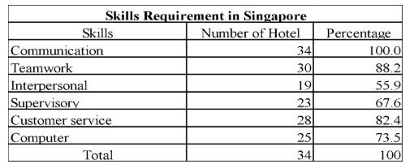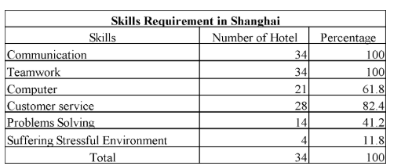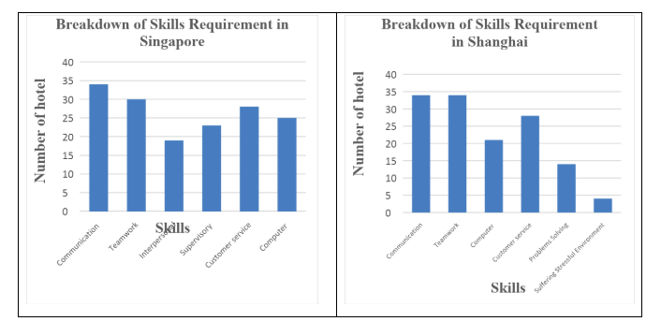

The bar charts illustrate the picture of skills division in both 2 countries in terms of Communication, Teamwork, Interpersonal, Supervisory, Customer service and Computer skills. Surprisingly, the Communication, Teamwork, Interpersonal and Customer services skills are the top 3 skills that both countries require when they employ the Front Office position. In Singapore, 100% employers require the Communication skills, which matches Shanghai’s results. Teamwork skill in Singapore is required by 30 employers, which is lower than Shanghai by 1.8%. Computer skills required by Singaporean’ employers are higher than Shanghai by 1.5%.

Both countries have the same proportion of Customer service skill of 82.4%. Interpersonal, supervisory, problem solving skills were a few others to be listed.

## Discussion

#### Experience

From the results, we are able to establish that the 80% of hotels in both Singapore and Shanghai require candidates to have work experience to be applicable to work at their hotels. A reason for requiring job experience would be that the candidates would have experience of different workplace settings, greater empathy and communication skills, and an understanding of key community needs. (McArthur, 2012).

The requirement of 3 to 5 years of experience is lesser than 1 to 2 years. This may be because some hotels feel that if a candidate already has a few years of experience in the industry, they might acquire or pick up some bad habits from past working areas which they will then bring into their new workplace and influence the other employees. Another reason may be that candidates with more experience will generally ask for a higher starting pay (Reddy, 2013).

20% of hotels in both Singapore and Shanghai do not require any past experience to work at their hotels. This suggests that on the job training will be provided.

#### Language

These days, English and Chinese are among the most commonly spoken languages around the world. In Singapore, majority of the population are able to speak both. Therefore, it is understandable that 100% of the hotels require their staff to be fluent in both languages. As Singapore is a multiracial country inclusive for ethnic Chinese, Malays and ethnic Indians, 6% of hotels require their staff to speak basic Malay or Tamil.

Although the main language in Shanghai is Chinese, China receives over 120 million tourists a year. (China Travel guide, 2017) With such a booming figure, the industry knows that in order to accommodate the tourists, basic English is a must thus hotels in Shanghai make English and Chinese a requirement for their staff. Despite Chinese being the main language in China, different dialects of it is spoken in different areas of China. The main dialect spoken in Shanghai is Cantonese and Min Dong therefore 9% of hotels in Shanghai also require their staff to be able to speak these dialects as well besides English and Chinese. As they will be communicating with hotel guest on a daily basis, they must be able to understand and speak fluently to avoid miscommunication.

#### Education

61.8% of hotels in Singapore require a diploma or higher to be applicable to work for the hotel. This shows that hotels in Singapore really value education and it implies that the higher your education level is, the more attractive you are to hotels when they are looking to hire.

9% more of hotels in Singapore would rather hire N/O level candidates rather than other certificates. This may be due to the fact that the N/O level certificates are sanctioned by the Ministry of Education Singapore and is recognized throughout Singapore while the other certificates obtained are from private organizations which are not as recognized.

15% of hotels in China are more willing to hire candidates with other certificates rather than a license which shows that they value education over experience in their employees.

#### Working attitude

In Singapore, responsibility is a key virtue especially in the hotel industry. If the front line staff is not responsible, wrong allocations of rooms or misplacing of customer’s luggage would happen and it would lead to unsatisfactory customer service hence there is no surprise that being responsible is the most listed attitude. Being approachable and confident was the second most commonly listed attitude. I believe this is also very important as a front line staff because you are communicating and dealing with customers on a daily basis. If you were to have a bad attitude or are too shy to talk to customers, they might not feel welcome and therefore look for a new hotel the next time they come back.

In Chinese culture, being efficient and is very important. They have the mentality to always get things done fast and well. (Lynton, 2013) This would explain 67.6% of hotels in Shanghai listing being efficient and courteous as a requirement. Chinese people are also very particular about the concept of dignity or prestige. This may sometime be a negative as some individuals may be too proud to ask for help when needed. I think this links in with being independent as one of the necessary skills. It is surprising to see that being listed as an important attitude as the hospitality industry is all about working together. A hotel can be run by one person, every staff needs to help each other out to ensure the operations run smoothly, with 50% of hotels having listed this in the job advertisement, it really is very surprising. The least common attitude that appeared was high integrity and confidence with only 17.6% of hotels listing that. As mentioned above, Chinese people are very particular about dignity and “face” therefore they generally would more honest and tend to not do the wrong thing such as steal customers’ belongings.

#### Skills

Straight away we are able to state that the top 3 skills required for hotels in both Singapore and Shanghai are communication, teamwork and customer service. This is of no surprise as:

1. The hospitality industry is providing a service to customer which makes it obvious that the customer service must be good if you want the hotel guests to return on their next trip
2. Without teamwork, the hotel operations would not be able to run smoothly, a hotel can’t be run by 1 person. The entire team needs to work together to ensure all departments are able to operate well together
3. If the different departments of the hotels do not communicate it would also affect the hotel’s operation as mistakes will start to happen without communication.

Both Singapore and Shanghai also require their front line employees to have basic computer skills. This might be to ensure no mistakes or hiccups occur during the checking in and out for guests staying at the hotel.

It is also interesting to see a few hotels in Shanghai listing ‘problem solving’ as one of their required skills as personally, I see it as being an important skill as problem solving skills are able to enhance communication and teamwork skills (Career Builder, 2017).

# Limitations

Although the research has reached its aims, there were some unavoidable limitations. This particular project was mainly limited by location, range chosen and type of data. First of all, this research was only carried out in two locations, which is Singapore and Shanghai, China. There may have been different results in more rural areas, or even larger cities. The results may have been seen as more accurate if there were more locations reached such as Western countries. Moreover, if the study could be done in different regions from all over the world, the results will be more interesting and various because it would be presented differently whereas the comparison between Singapore and Shanghai is not much different.

Secondly, this report has only chosen 3-5 star hotels as the range of conducting the research, so there is only a small number of hotel chosen. Different hotels have different requirement as well as expectations from candidates. If the research has chance to discuss the topic in term of all types of hotel which includes budget hotels and high-end hotels, it could analyze wide aspects of requirements of the front office. From that point, the research could provide accurate and specific results.

Last but not the least, there is only qualitative data is given. The data is only collected from job advertisements on websites which is not enough for this kind of research. To be more specific and get more factual data, the study should have used other sources such as hospitality magazines and more other previous discussions. This kind of research should be done within quantitative in term of questionnaire method which could bring more detailed and accurate information and data. Particularly, this research just collects secondary data from website. Whereas, if we use the questionnaire for interviewing employers of hotels, agencies or tourists, they will provide the objective views which is a good data for the research.

Avoiding these limitations to the maximum extent possible in future studies will improve the accuracy of the results, the accuracy of the study and the effectiveness of its impact.

# Conclusions and Recommendations

##### Conclusions

In conclusions, this research has analyzed the requirements of employers for hotels frontline office in Shanghai, China and Singapore and points out some conclusions and recommendations. Base on what we have done above, there are five common requirements for hotel frontline staff which are: Experience, Languages, Education, Working attitude and skills.

Experience is one of significant requirements for any hotel employees, especially high-end hotels. The frontline staff are usually required to have experience from 1 years to 5 years depending on each position and hotel’s demand. The majority of hotels in Singapore and Shanghai respectively want to hire people who have 1 to 3-years experiences; the small number of hotel look for people having 3 – 5 years experiences. Moreover, there are also some hotels offer free entry level for the staff.

Because Singapore and Shanghai are well-known tourism destination in the world, English is basically and significantly requirements for hotel staff and frontline staff is no exception. Besides, especially Chinese is common language in these two nations that is reason why most of hotel will prefer those people speaking Chinese too. Other languages such as Japanese, French, Germany are also required for some particular hotels.

As most of hotel in Shanghai and Singapore want to employ candidates who have diploma or bachelor in term of hospitality and tourism sector. The rest of hotels require others certification which is relevant to hotel industry.

Working attitude is a significantly requisite requirement to front office because they directly work with customer. Therefore, most of hotel expect to hire people who are charming and confident, positive and responsible with work as well as international minded and willing to learn. Besides attitude, frontline staff need to have basic skills such as communication, teamwork, computer and customer services which those hotels in Shanghai and Singapore both require. Furthermore, interpersonal, supervisory, problems solving and suffering stressful environment are requisite skills being asked in some hotels.

##### Recommendations

This research shows the specific conditions of hotel staff and understands the skills needed in the future. The following recommendations are for future research in this area of study and also to the hotels in the industry on how to eliminate the problem of having under qualified staff.

The research found that the License certificate is only 14.7% primary criteria to employ Front Office Staffs in Shanghai. Hotel in Shanghai is more willing to hire candidates with other certificates rather than a license which shows that they value education in their employees. As the recommendation, if hotels in Shanghai want to improve the quality of hotel services, they should pay attention to the license of the front desk staff as well as other certificates.

As a suggestion to the hotel, the key to solving a series of problems that need to be solved, such as low staff quality, backward skills, unbalance of human resource allocation and low level of training, is to investigate the specific situation of the staff and provide continuous training for employees.

As one of our limitations was the location and the study being carried out in only 2 cities of the world, it would benefit greater if a study could be conducted in a different continent or other countries. The results then compared would help us better understand the requirements of front line staff in the hospitality industry.

**References**

AccorHotels. (2018). *Accorhotels Jobs: Accorhotels Job and Traineeship in Hospitality, Catering and Support Professions Around the World For Accorhotels Hotels*. Retrieved from [https://www.accorhotels.jobs/Job-vacancy/Front-office-management-trainee+Pullman-shanghai-skyway,j,0,428459.html?FromPartnership =indeed](https://www.accorhotels.jobs/Job-vacancy/Front-office-management-trainee+Pullman-shanghai-skyway,j,0,428459.html?FromPartnership%20=indeed)

Agent-Front Desk/Exec Floor上海市招聘 - 找工作. (2018). Retrieved from <https://cn.indeed.com/viewjob?jk=4104982bf614c0f3&tk=1cclbv2us0sq55er&from=serp&vjs=3>

Assistant Front Office Manager - Orchard Parade Hotel Job - Far East Hospitality. (2018). Retrieved from <https://www.jobstreet.com.sg/en/job/assistant-front-office-manager-orchard-parade-hotel-6423451?fr=23&src=12>

Assistant Guest Services Manager Job - Four Points by Sheraton Singapore, Riverview. (2018). Retrieved from <https://www.jobstreet.com.sg/en/job/assistant-guest-services-manager-6450307?fr=J&src=16&srcr=12>

Assistant Reception Manager - Front Office Job - Shangri-La's Rasa Sentosa Resort & Spa, Singapore. (2018). Retrieved from <https://www.jobstreet.com.sg/en/job/assistant-reception-manager-front-office-6446701?fr=23&src=12>

Career Builder. (2017, June 13). *What are problem-solving skills and why are they important?* Retrieved from: <https://www.careerbuilder.com/advice/what-are-problemsolving-skills-and-why-are-they-important>

Career Opportunities: Service Associate - In Room Dining / 宾客服务员 - 送餐部. (2018). Retrieved from <https://career4.successfactors.com/career?career_ns=job_listing&company=ShangriLa&navBarLevel=JOB_SEARCH&rcm_site_locale=en_GB&career_job_req_id=87689&selected_lang=en_GB&jobAlertController_jobAlertId=&jobAlertController_jobAlertName=&_s.crb=GF5AO6AdKnnN8XW5pC/6jRjsX9c&jobPipeline=Indeed>

China Travel guide. (2017). *China Tourism*. Retrieved from: <https://www.travelchinaguide.com/tourism/>

Customer Service Specialist (International) - Shanghai, China (Shanghai). (2018). Retrieved from <https://www.asiahospitalitycareers.com/display-job/69799/Customer-Service-Specialist-(International)--Shanghai,-China.html?searchId=1525051361.4483&page=1>

Ecole Hoteliere Lausanne. (2018). *A Promising Outlook for The Hospitality Industry*: *WTTC publishes 2017 World Economic Impact on Travel & Tourism Report*. Retrieved from <http://www.ehl.edu/en/news/promising-outlook-hospitality-industry-wttc-publishes-2017-world-economic-impact-travel-tourism>

Front Desk Supervisor Job - Hotel Bencoolen Co Pte Ltd. (2018). Retrieved from <https://www.jobstreet.com.sg/en/job/front-desk-supervisor-6448627?fr=23&src=12>

Front Office 上海市 - Guest Relation Agent/Officer招聘 - 找工作. (2018). Retrieved from <https://cn.indeed.com/viewjob?jk=a16dc4863ffb85c9&tk=1ccil74670sqf28b&from=serp&vjs=3>

Front Office Agent 上海市 长宁区前厅接待招聘 - 找工作. (2018). Retrieved from <https://cn.indeed.com/viewjob?jk=f0d9996684cdb9cc&tk=1ccilvstb0sqf6v2&from=serp&vjs=3>

Front Office Executive. (2018). Retrieved from <https://www.careerjet.sg/jobview/5407a5db8c84f35d869a544b4ccc2cbe.html>

Front Office Executive, InterContinental Singapore. (2018). Retrieved from <https://www.careerjet.sg/jobview/529c821090bf683644e53654e44bba7a.html>

Front Desk Executive Job - JW Marriott Hotel Singapore South Beach. (2018). Retrieved from <https://www.jobstreet.com.sg/en/job/front-desk-executive-6464065?fr=21&src=16&srcr=12>

Front Office Agent (Japanese-Speaking) Job - Marina Bay Sands Pte Ltd. (2018). Retrieved from <https://www.jobstreet.com.sg/en/job/front-office-agent-japanese-speaking-6442820?fr=23&src=12>

Front Office Associate Job - Ramada & Days Hotels Singapore. (2018). Retrieved from <https://www.jobstreet.com.sg/en/job/front-office-associate-6428749?fr=J&src=12>

Front Office Executive Job - Arton Boutique Hotel. (2018). Retrieved from <https://www.jobstreet.com.sg/en/job/front-office-executive-6412898?fr=23&src=12>

Front Office Executive Job - Grand Mercure Roxy Hotel. (2018). Retrieved from <https://www.jobstreet.com.sg/en/job/front-office-executive-6374115?fr=J&src=16&srcr=12>

Front Office Manager上海市前厅经理招聘 - 找工作. (2018). Retrieved from <https://cn.indeed.com/viewjob?jk=4d462a60a2759f1d&tk=1ccilvstb0sqf6v2&from=serp&vjs=3>

Front Office Manager. (2018). Retrieved from <https://hilton.taleo.net/careersection/hww_external/jobdetail.ftl?lang=en&job=1098986&src=JB-11960>

Front Office Manager Job - Ibis Singapore Novena. (2018). Retrieved from <https://www.jobstreet.com.sg/en/job/front-office-manager-6438321?fr=23&src=12>

Front Office Receptionist Job - Novotel Singapore Clarke Quay. (2018). Retrieved from <https://www.jobstreet.com.sg/en/job/front-office-receptionst-6438652?fr=23&src=12>

Gallery Host 上海市- Front Office / F&B招聘 - 找工作 | Indeed.com. (2018). Retrieved from <https://cn.indeed.com/viewjob?jk=1774dbc47053821a&tk=1ccids5u20sqf5ck&from=serp&vjs=3>

Guest. (2018). Retrieved from <https://jobs.disneycareers.com/job/-/-/391/6269350?codes=INDEED>

Guest Service Agent (Permanent Night Shift) Job - Hotel Splendour Pte Ltd. (2018). Retrieved from <https://www.jobstreet.com.sg/en/job/guest-service-agent-permanent-night-shift-6401053?fr=21&src=16&srcr=12>

Guest Service Agent Job - Oxford Hotel Pte Ltd. (2018). Retrieved from <https://www.jobstreet.com.sg/en/job/guest-service-agent-6444163?fr=J&src=16&srcr=12>

Guest Service Officer Job - Park Regis Singapore. (2018). Retrieved from <https://www.jobstreet.com.sg/en/job/guest-service-officer-6398331?fr=21&src=44>

Guest Service Officer Job - The Seacare Hotel. (2018). Retrieved from <https://www.jobstreet.com.sg/en/job/guest-service-officer-6420893?fr=21&src=16&srcr=12>

Guest Services Executive - Front Office (Native Japanese-speaking) Job - Marina Mandarin Singapore. (2018). Retrieved from <https://www.jobstreet.com.sg/en/job/guest-services-executive-front-office-native-japanese-speaking-6416270?fr=23&src=12>

Guest Services Executive Job - Mandarin Oriental, Singapore. (2018). Retrieved from <https://www.jobstreet.com.sg/en/job/guest-services-executive-6426662?fr=21&src=12>

Guest Services Executive Job - Park Hotel Clarke Quay. (2018). Retrieved from <https://www.jobstreet.com.sg/en/job/guest-services-executive-6444490?fr=J&src=16&srcr=12>

Guest Services Executive Job - The Legends Fort Canning Park Pte Ltd. (2018). Retrieved from <https://www.jobstreet.com.sg/en/job/guest-services-executive-6427986?fr=21&src=12>

Guest Service Officer 上海市 浦东新区前厅接待员 - Front Office 招聘 - 找工作. (2018). Retrieved from <https://cn.indeed.com/viewjob?jk=e18bbcf9c567a663&q=front+office+hotel&l=%E4%B8%8A%E6%B5%B7%E5%B8%82&tk=1ccimu2o40sqf04t&from=web&vjs=3>

Guest Services Officer (F&B) Job - Studio M Hotel Singapore. (2018). Retrieved from <https://www.jobstreet.com.sg/en/job/guest-services-officer-fb-6435985?fr=21&src=12>

Guest Services Officer (Pacific Club) Job - The Pan Pacific Hotel Singapore. (2018). Retrieved from <https://www.jobstreet.com.sg/en/job/guest-services-officer-pacific-club-6461602?fr=21&src=12>

Guest Services Officer Job - Courtyard by Marriott Singapore Novena. (2018). Retrieved from <https://www.jobstreet.com.sg/en/job/guest-services-officer-6459312?fr=21&src=12>

Guest Services Officer Job - Orchid Hotel Pte Ltd. (2018). Retrieved from <https://www.jobstreet.com.sg/en/job/guest-services-officer-6402857?fr=21&src=16&srcr=12>

Guest Services Officer Job – Park Royal on Pickering. (2018). Retrieved from <https://www.jobstreet.com.sg/en/job/guest-services-officer-6414424?fr=21&src=16&srcr=12>

Hai‐Yan, K., & Baum, T. (2006). *Skills and Work In The Hospitality Sector: The Case Of Hotel Front Office Employees In China*. International Journal of Contemporary Hospitality Management, 18(6).

Help Us Keep Glassdoor Safe. (2018). Retrieved from <https://www.glassdoor.com/job-listing/front-office-manager-marriott-JV_IC2398510_KO0,20_KE21,29.htm?jl=2588747902&ctt=1525054892888>

Host - Front Office Job - Andaz Singapore. (2018). Retrieved from <https://www.jobstreet.com.sg/en/job/host-front-office-6432611?fr=23&src=12>

ISC Supervisor 上海市 黄浦区快捷服务中心主管招聘 - 找工作. (2018). Retrieved from <https://cn.indeed.com/viewjob?jk=601f41fb81720e9b&tk=1ccimu2o40sqf04t&from=serp&vjs=3>

Job Number. (2018). Retrieved from <https://cn.indeed.com/viewjob?jk=63fd0c3724003280&tk=1ccil74670sqf28b&from=serp&vjs=3>

Lynton, N. (2013, July). *Managing the Chinese way*.

Retrieved from Mckinsey: <https://www.mckinsey.com/featured-insights/asia-pacific/managing-the-chinese-way>

Management Trainee上海市 - Front Office招聘 - 找工作. (2018). Retrieved from <https://cn.indeed.com/viewjob?jk=95fe522c3ab74abb&tk=1ccids5u20sqf5ck&from=serp&vjs=3>

McArthur, W. (2012). *The Advantages of Experience-Based Learning*. Retrieved from: <https://www.topuniversities.com/student-info/careers-advice/advantages-experience-based-learning>

Officer, Guest Service Job - The Ascott Limited. (2018). Retrieved from <https://www.jobstreet.com.sg/en/job/officer-guest-service-6460731?fr=J&src=16&srcr=12>

Reddy, C. (2013). *Advantages and Disadvantages of Work Experience*.

Retrieved from: <https://content.wisestep.com/advantages-disadvantages-work-experience/>

Reservations Manager Job - Le Méridien Singapore, Sentosa. (2018). Retrieved from <https://www.jobstreet.com.sg/en/job/reservations-manager-6428325?fr=21&src=16&srcr=12>

Saunders, M., Lewis, P., & Thornhill, A. (2016). *Research methods for business students*. Harlow, Essex, England: Pearson Education Limited.

Schoemaker, P.J.H. & Russo, J.E. (1993). *A Pyramid of Decision Approaches*. California Management Review, Fall, 9-31.

STJobs, S. (2018). *Singapore Job Classifieds & Online Jobs Classifieds, Singapore Job Search*. Retrieved from <http://www.stjobs.sg/front-office-executive-job/view-job/1632149>

SO Welcome Angel (Front Office) Job - Sofitel So Singapore. (2018). Retrieved from <https://www.jobstreet.com.sg/en/job/so-welcome-angel-front-office-6440461?fr=23&src=12>

Wanless, T. (n.d). *The Good, Bad, And Ugly of Decision Making*. Retrieved from <http://www.bcbusiness.ca/your-business/the-good-bad-and-ugly-of-decision-making>

Westford School of Management. (n.d). *The Importance of Front Office in Tourism and Hospitality Industry*. Retrieved from <http://www.mywestford.com/the-importance-of-front-office-in-tourism-and-hospitality-industry/>

**APPENDIX**

Table 1: Summary of results collated from Job advertisements in Singapore and China

